**Type Script Language**

**Language Basics**

* Variables
* Data Types
* Operators
* Statements
* Functions

**Variables in TypeScript**

* Variables are storage locations in memory, where you can store a value and use it as a part of any expression.
* Variable Configuration comprises of 3 stages
  + Declaration
  + Rendering / Assigning
  + Initialization

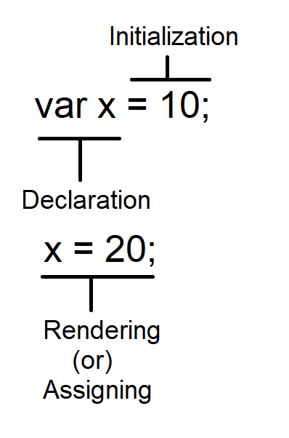

* JavaScript can directly assign or render a value into variable without any declaration if it is not in strict mode.
* If JavaScript is in strict mode the declaring variable is mandatory.
* TypeScript is by default using strict mode of JavaScript.
* In TypeScript declaring variable is mandatory.
* You can declare variables in TypeScript by using 3 keywords
  + var
  + let
  + const

|  |  |
| --- | --- |
| **Keyword** | **Description** |
| var | * It defines a function scope for variable. * You can declare any where in a function and access from any block in the function. Ex:   function f1()  {  var x = 10;  if(x==10)  {  var y = 20;  }  console.log(`x=${x}\ny=${y}`);  }  f1();   * It supports *declaration*, *rendering* and *initialization*.  Ex:   function f1()  {  var x; // declaration  x = 10; // rendering  if(x==10)  {  var y = 20; // initialization  }  console.log(`x=${x}\ny=${y}`);  }  f1();   * It supports shadowing. * **Shadowing** is the process of re-declaring same name identifier within the given scope. Ex:   function f1()  {  var x = 0;  x=10;  if(x==10){  var x = 20; // shadowing  }  console.log(`x=${x}`);  }  f1();   * It allows **Hoisting**. * It is a technique following by compiler to identify the variables declaration before rendering. * Var support hoisting hence there is no order for declaring and rendering. You can first define the rendering block then following by declaration block.   Ex:  function f1()  {  x = 10;  console.log(`x=${x}`);  var x; // hoisting  }  f1(); |
| let | * It defines block scope variable. * It can be accessed only within the block where it is declared. * You can’t access outside the block.   Ex:  function f1()  {  let x;  x=10;  if(x==10)  {  let y = 20; // block scope  console.log(`x=${x}\ny=${y}`); **// OK**  }  console.log(`x=${x}\ny=${y}`); **// y not defined**  }  f1();   * let allows declaration, rendering and initialization.   Ex:  function f1()  {  let x; // declaring  x=10; // rendering  if(x==10)  {  let y = 20; // initialization  console.log(`x=${x}\ny=${y}`);  }  }  f1();   * let will not allow **Shadowing**. * You can’t re-declare same name identifier in the block. * let will not allow **Hoisting.** |
| const | * It defines block scope variable. * It will allow only initialization. * It will not allow declaring and rendering. * It will not allow shadowing. * It will not allow hoisting. |